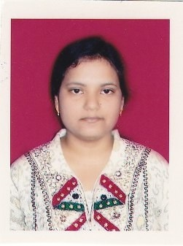
- Name: Ms Ritisnigdha Mishra
- Designation: Guest Faculty
- Date of Joining: 8/8/16
- Department: Chemistry
- Contact No: 8280089006
- E-mail ID: mishra.ritisnigdha@gmail.com
- Educational Qualification:
Sl. No | Qualification | Year of Passing | Subject | Name of University
1. | M.Sc. | 2013 | Chemistry | Berhampur University
2. | M.Phil | 2015 | Chemistry | Berhampur University
- Seminar/conference/Symposium/Workshop attended

Sl. No | Seminar/ conference | Name | Sponsoring Agency | National/  international
1. | Conference | Innovative Application of Chemistry in Pharmacology and Technology | UGC  Berhampur, 2015 | International
2 | Seminar | International year of Chemistry | UGC  Berhampur, 2011 | National

- Seminar/conference/Symposium/Workshop Conducted- NIL
- Number of Books/Journals Published- NIL
- Paper Published in National & International Journals-NIL
- Research Project
- Whether awarded Ph.D.-

