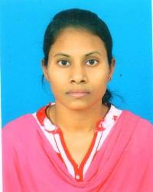
- Name: Ms Archana Kumari Pradhan
- Designation: Guest Faculty
- Date of Joining: 11/07/18
- Department: Chemistry
- Contact No: 8596844416
- E-mail ID: pradhanarchana1993@gmail.com
- Educational Qualification:
Sl. No | Qualification | Year of Passing | Subject (PG onwards) | Name of University
1. | M.Sc. | 2016 | Chemistry | Berhampur University
2. | M.Phil | 2018 | Chemistry | Khallikote University
- Seminar/conference/Symposium/Workshop attended

Sl. No | Seminar/  conference | Name | Sponsoring Agency | National/  international
1. | Seminar | National Seminar On Recent Advances In Functional Nano Materials | Orissa Chemical Society | National
2. | Seminar | Chemical & Biological science In Drug Discovery | UGC  Berhampur2019 | International

- Seminar/conference/Symposium/Workshop Conducted –NIL
- Number of Books/Journals Published -NIL
- Paper Published in National & International Journals-NIL
- Research Project
- Whether awarded Ph.D.
- Research Guidance

